**How to Run the code:**

1. First Run “langchain_kavya.ipynb” [google colab]

* Run all packages and cells step by step.

“#docsearch = PineconeVectorStore.from_documents(docs, embeddings, index_name='nlpproject')

* Above cell is commented Don’t run this cell. Because Embeddings are already stored in Pinecone vector Data Store. If you run it again Duplicate Vectors will be created.
* Run remaining cells similarly

1. Run “graph.py” in local VSC.

* Install streamlit in local by running “!pip install streamlit pyngrok”.
* Then go to the directory containing graph.py file and run “streamlit run graph.py”
* This will display Streamlit Interface similar to below, where you check check the results of RAG.

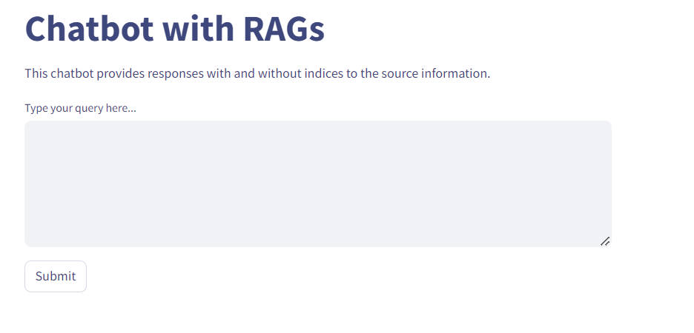

1. Run “Trulens_RAG.ipynb” in Google Colab.

* Run all cells.
* When you run “tru.run_dashboard()” cell. You will get a URL like below

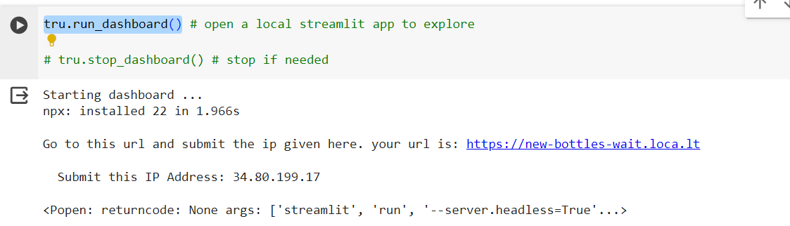

* Go to the link and type the IP Address as password.
* You will get Streamlit Interface showing Evaluation of RAG.